|  |  |  |
| --- | --- | --- |
| **STA 672** | **Fall 2015** | **Test** |

**DO ONLY 2 OF THE 4 PROBLEMS** – The first two columns must be *filled in\** and this page *submitted* with any work you wish to have considered for credit.

|  |  |  |
| --- | --- | --- |
| Name __________________________ | Problem  # | Points |
| First problem (number)  to be graded: |  | /20 |
| Second problem (number)  to be graded: |  | /20 |
| Total: |  | / 40 |

This test is open-book, open-note—you may use any resource you wish other than the help of another human being. All cell phones must be ***turned off*** (not in vibration-only mode,) or the person not following this instruction will not be allowed to turn his/her exam for credit.

*Submission with more or fewer than two numbers to be graded will be returned for no credit.

#1. A statistics instructor has noticed, while blowing up balloons for his granddaughter’s birthday party, that balloons of different colors seem to vary in the amount of time to blow up. He decides this is worthy of research, and with a package of 100 balloons (20 of each color: red, pink, yellow, blue, and orange) and the help of a team of poor starving teaching assistants (TAs) working for pizza, he has each of the five TAs pull a random color out of a hat. Whichever color they draw is the color of balloon they will be inflating in the experiment—blowing up each balloon to its target diameter of 7 inches, with the instructor using a stopwatch to record each time to the nearest tenth. The TAs proceed in order—red, pink, yellow, blue, orange—giving them time to recover between balloons.

(a) (5 points) Identify the following elements of their experiment:

i) Research question:

Does balloon color affect inflation time?

ii) Factor(s):

As stated, color/TA, as there is no separation of the two.

iii) Treatment(s):

Color of balloon.

(b) (7 points) Is this a well-designed experiment? If not, explain what is wrong and how it could be improved.

While there is randomization (color to a TA) and time allowed to rest (no “echo” effect, so some effort at independence between observations of the same color,) assignment of all the balloons of the same color to a single TA results in no (actual) replication, so we have pseudoreplication—so we don’t get power to distinguish possible difference between means we wish (colors) and means that are nuisance (TAs’ abilities to blow up balloons. Could be improved by having TAs blow up different colors (see suggestion 3.)

(c) (8 points) Some suggestions for investigating the instructor’s research question:

* Suggestion 1: Average the inflation times across each color, comparing the averages for each color to determine any variations in the inflation times.

weakness mentioned above.

* Suggestion 2: Randomly assign a new color balloon to each TA on each round, at the end comparing the averages for each color to determine any variations in the inflation times.

has the advantage of actual replications (TAs blowing up different colors,) but may not be balanced

* Suggestion 3: Randomly assign a color to the 5 TAs, having them blow up five balloons of that color—each successive five balloons, randomly assign each TA to a color he/she hasn’t inflated yet. At the end, compare the averages for each color, using the TAs as a blocking variable.

best suggestion, with randomization and replication (of 4) for each color with blocking variable of TA.

Comment on the three suggestions. Explain which solution is best approach to answer the instructor's research question and also explain what is wrong with the other two. (comments, including which is best, above.)

#2. An experiment on the efficacy of nail varnish solvent in removing nail varnish from cloth was run using two sorts of varnish and two sorts of varnish solvent and is excerpted here:

|  |  |  |
| --- | --- | --- |
| **Varnish** | **Varnish Solvent** | |
| 1 | 2 |
| 1 | 27.58, 28.75, 25.83, 29.25, 22.08 | 29.17, 31.75, 32.08, 28.50, 31.25 |
| 2 | 22.50, 25.17, 27.75, 21.50, 25.00 | 34.42, 26.00, 31.08, 29.17, 24.75 |

The response variable is time (in minutes) for the varnish to dissolve from the cloth.

(a) (6 points) Write down the cell means model for the data and identify the components.

$$y_{ijk}=μ_{ij}+ε_{ijk}$$

where

$y_{ijk}=$ time to dissolve for $i^{th}$ varnish, $j^{th}$ solvent, $k^{th}$ observation

$μ_{ij}=$ mean time to dissolve for $i^{th}$ varnish, $j^{th}$ solvent

$ε_{ijk}=$ error for $k^{th}$ observation using $i^{th}$ varnish, $j^{th}$ solvent; difference between $y_{ijk}$ and $μ_{ij}$

(b) (4 points) Use the JMP output as necessary to decide whether the efficacy of the two varnish solvents in removing nail varnish depended on the type of varnish.

This semester, you would receive SAS output, but more important that we recognize that this is asking about the interaction between the two factors: the simple effect of varnish solvent depending on the type of varnish:

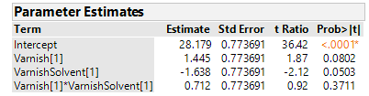

Based on this output, since p-value>0.05, no significant interaction 🡪 therefore, decide the efficacy of the two varnish solvents does not depend on the type of varnish.

(c) (4 points) The researcher’s decision was that the interaction between nail varnish and nail varnish solvent was negligible, so that term has been removed from subsequent JMP analyses for this problem. Using these, would you decide there is a significant effect of the different solvents in efficacy in removing varnish from cloth?

In subsequent analysis, we get:

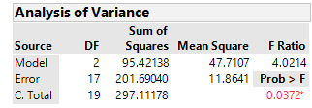

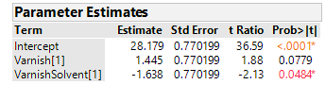

showing a significant coefficient on varnish solvent (< 0.05,) therefore we conclude there is a significant effect of the different solvents.

(d) (6 points) Consistent with your answers to the previous parts, use the appropriate JMP analysis (some additional are included) for the significant effect in this model. Tell me which effect you are reporting, why, and what the *comparison*-wise error rate would have been.

In (c), we declared varnish solvent significant (as a regressor of solution time,) so the second output would be appropriate,) so assuming an overall error rate of 0.05, the comparison-wise error rate would be 0.05/2 = 0.025, or Lower 100(1-0.025/2)% = 98.75% CIs. **🡨 this is the t-quantile needed, but the error rate is .025, and the confidence level is just 97.5. Thanks for a couple of people pointing this out. Again, went crazy dividing by 2!**



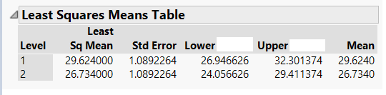

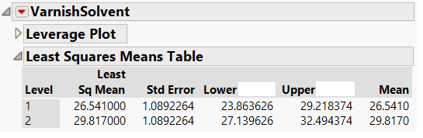



#3. The data from problem #2 are repeated here (an experiment on the efficacy of nail varnish solvent in removing nail varnish from cloth was run using two sorts of varnish and two sorts of varnish solvent):

|  |  |  |
| --- | --- | --- |
| **Varnish** | **Varnish Solvent** | |
| 1 | 2 |
| 1 | 27.58, 28.75, 25.83, 29.25, 22.08 | 29.17, 31.75, 32.08, 28.50, 31.25 |
| 2 | 22.50, 25.17, 27.75, 21.50, 25.00 | 34.42, 26.00, 31.08, 29.17, 24.75 |

a) (3 points) What assumption about a blocking variable and the factor of interest can be justified using the first JMP output? Explain your answer.



Based on this output, since p-value>0.05, no significant interaction 🡪 therefore, decide the efficacy of the two varnish solvents does not depend on the type of varnish.

b) (6 points) Fit the analysis of variance model using the 2 varnishes as a blocking factor, testing for an effect of different solvents on the time at the ** = 0.05 level of significance. State the hypotheses in words, identify the appropriate test statistic and *p*-value, and state your conclusion.

H0: different varnish solvents, when allowing for the effects of varnish, have no effect on the average solution time

Ha: different varnish solvents, when allowing for the effects of varnish, have an effect on the average solution time





The overall F doesn’t (in the case of a blocking factor) doesn’t tell us anything (meaningful) – here, it would tell us that among all the varnish * varnish_solvent combinations, one of the mean solution times is different 🡪 not meaningful, and not news, if we are using a blocking variable. Should have pointed at the t-statistic for varnishsolvent (which is adjusted for the effect of varnish) in the second table, -2.13, and its p-value of 0.0484, still significant. Thanks, Y.L.!

c) (6 points) Fit the analysis of variance model ignoring the effect of the two varnishes, testing for an effect of different solvents on the time at the ** = 0.05 level of significance. State the hypotheses in words, identify the appropriate test statistic and *p*-value, and state your conclusion.

H0: different varnish solvents have no effect on the average solution time

Ha: different varnish solvents have an effect on the average solution time

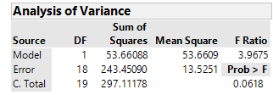

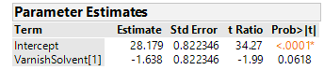

Here, because of the smaller F (3.9675,) and larger p-value (0.0618 > 0.05, we don’t reject H0, finding insufficient evidence to decide that different varnish solvents have an effect on solution time.

d) (5 points) Comment on the difference in the results in b) and c), citing specific outcomes and explain this difference.

The variability accounted for/attributed to the different varnishes in part b) allowed for rejection (accepting Ha, deciding different varnish solvents had different average solution times,) while in c), failing to account for/attribute that variability to its source didn’t let us reject the null/resulted in a smaller F/bigger p-value.

4. (Due to Larry Lesher) An experiment was run to determine whether pushing a certain pedestrian light button had an effect on how long the person had to wait before the light showed “walk.” The factor of interest was the number of pushes of the button. The data are reproduced here:

|  |  |  |  |  |
| --- | --- | --- | --- | --- |
| **Time in seconds for “Walk” sign to appear** | | | | |
| **Number of Pushes** | **0** | **1** | **2** | **3** |
| Time | 38.14 | 38.28 | 38.17 | 38.14 |
| 38.20 | 38.17 | 38.13 | 38.30 |
| 38.31 | 38.08 | 38.16 | 38.21 |
| 38.14 | 38.25 | 38.30 | 38.04 |
| 38.29 | 38.18 | 38.34 | 38.37 |

Use the JMP output on the handout where necessary to answer the following questions.

(a) (6 points) Write out the cell means model for this experiment and explain the components.

$$y_{ij}=μ_{i}+ε_{ij}$$

where

$y_{ij}=$ time for “Walk” sign to appear after $i^{th}$ pushes, $j^{th}$ observation

$μ_{i}=$ mean time for “Walk” sign to appear after $i^{th}$ pushes

$ε_{ij}=$ error for $j^{th}$ observation using $i^{th}$ pushes; difference between $y_{ij}$ and $μ_{i}$

(b) (6 points) Test for an effect of pushing the pedestrian light button on the waiting time at the $α=0.05$ level of significance. Clearly state your hypotheses, the appropriate test statistic and *p*-value, and your conclusion.

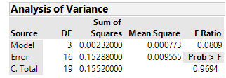

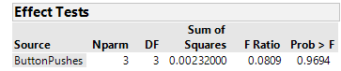

H0: different number of pushes have no effect on the average time until walk appears

Ha: different number of pushes have an effect on the average time until walk appears

ButtonPushes is wildly insignificant. Tiny F (0.0809), Huge p-value (0.9694, almost 1!) No effect of button pushes on average time until Walk appears observed.

(c) (2 points) Comment on the appropriateness (utility) of any further analyses on these data (considering number of pushes on the button as a factor.)

Since the single factor analyzed is insignificant no further analysis (contrasts, CIs, etc.) necessary/recommended/appropriate.

(d) (6 points) Regardless of your answer to part (c), explain what is being tested with the following option:

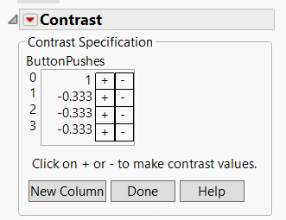

and output:

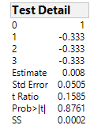

| **SS** | **NumDF** | **DenDF** | **F Ratio** | **Prob > F** |
| --- | --- | --- | --- | --- |
| 2e-4 | 1 | 16 | 0.0251 | 0.8761 |

summarizing the results of this procedure using an error rate of $α=0.05$, and explain how these results are consistent with those of part (b).

This tests for a difference in average time until Walk appears when one doesn’t push the button (Number of pushes = 0) versus pushing it at all (pushes = 1, 2, or 3.) As expected, given the lack of any significant difference of means in b), we find no difference here, with a “not quite as big, but still way too big to be significant” p-value of 0.8761.